**HJD Converter Plug-In**

Install the HJD Converter plug-in by going to the *Tool* menu and selecting the *Plug-In Manager*. AAVSO login is required. Scroll to and select the Heliocentric JD Converter file reader and click Install. After installation, restart VStar.

As an example, go to the VStar *File* drop down tab and select “New Star from ASAS File” and open the r_car_asas.txt file. This will give you:

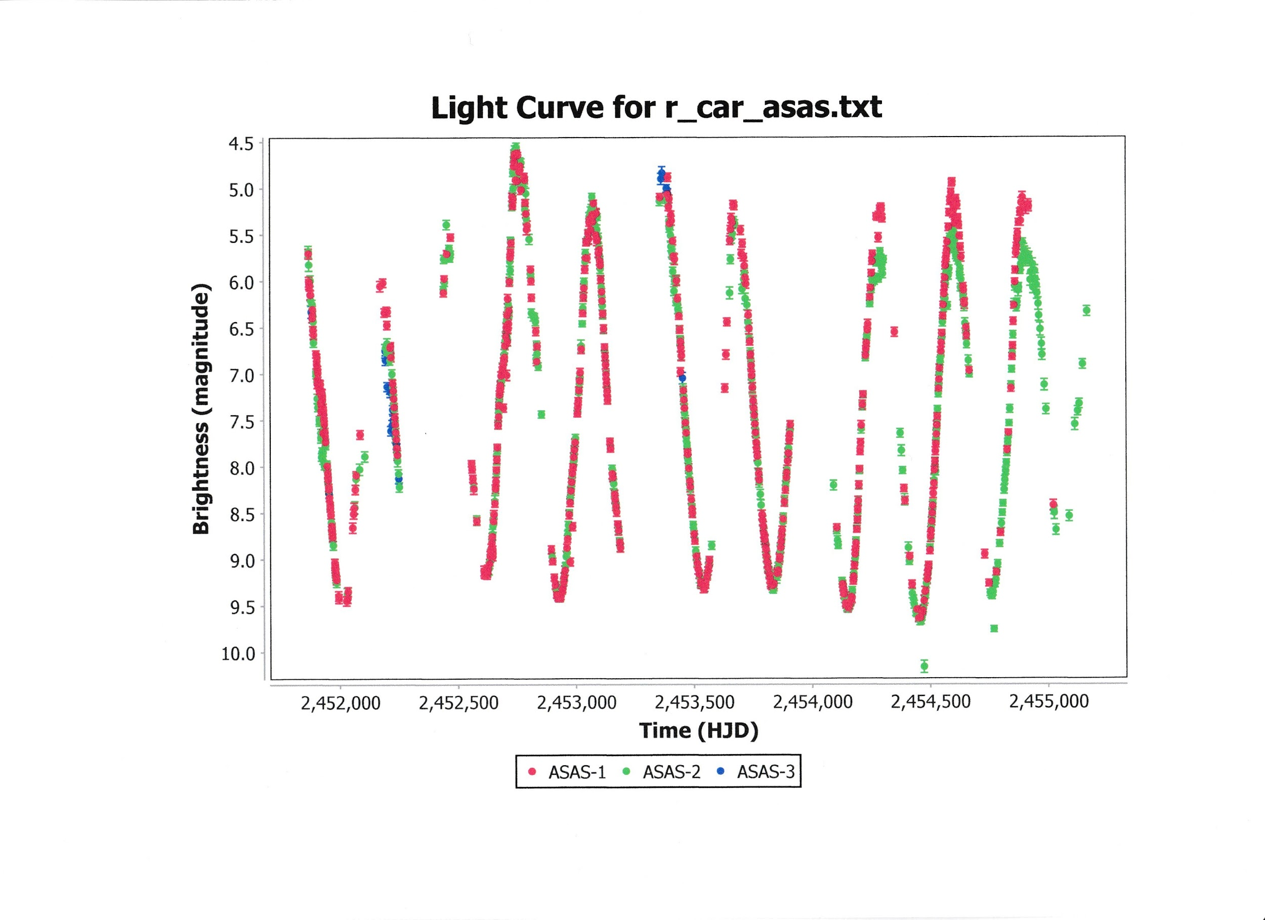

Next select “New Star from AAVSO Database”. Enter R Car in the “Star” field and replace Minimum JD with 2450500 and Maximum JD with 2451500. Check “Add to Current?” and click OK. This will yield the combined light curve:

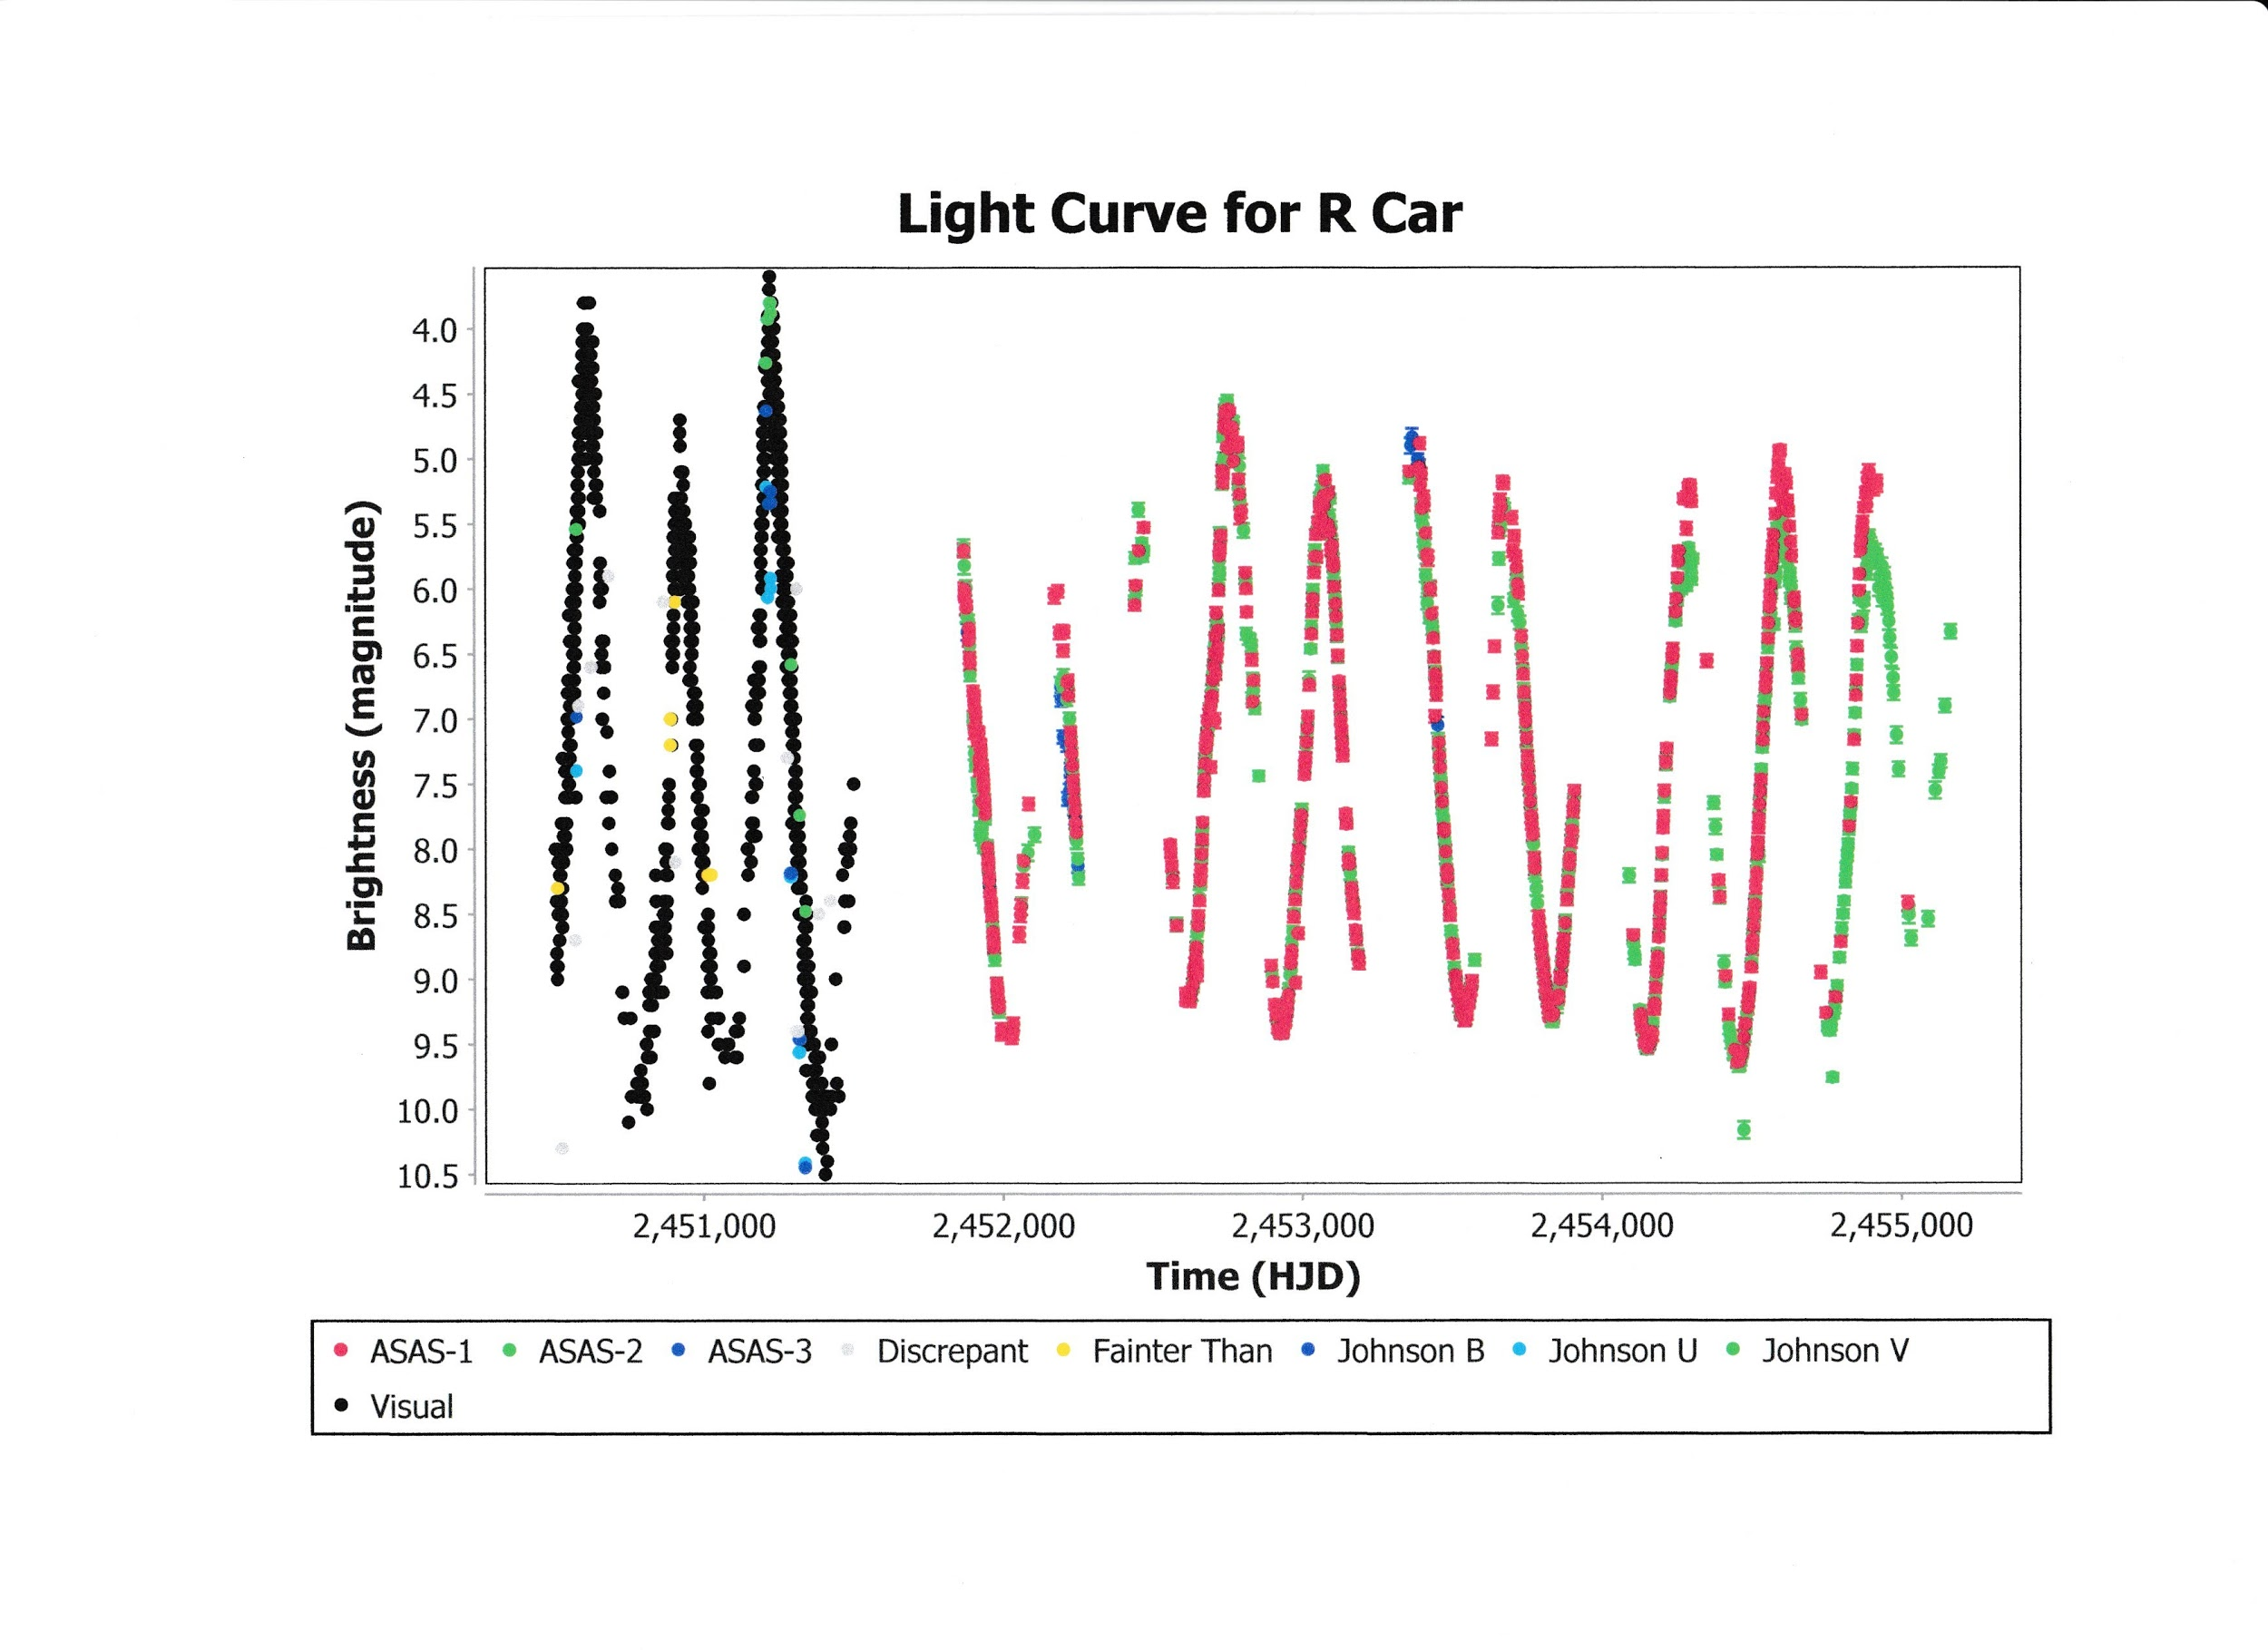

Go to the *Tool* drop down tab and select the “Heliocentric JD Converter” option. This yields the “Non-Heliocentric Datasets” window. Check the box for “AAVSO International Database observation source: R Car” and click OK. The “HJD Conversion” window will appear with the message “2228 observations converted”. Click OK.

From here, multiple VStar analysis options are available.

**NOTE: The HJD conversion currently assumes JD only. The HJD Converter plug-in currently does not convert BJD observations into HJD data.**